SMU Data Science Bootcamp *Zeinab MASSUDI*

**Unit 1 ⏐Assignment – KickStart My Chart**

1. **CONCLUSIONS**

The raw data, though limited in amount of information it provides, allows us to make a few conclusions about the success rate of the KickStarter campaigns.

1. Overall, **just over 1 in 2 (53%) campaigns were successful**. Top 3 most successful categories are Music (77%), Theatre (60%) followed by Film & Video (58%).

**Table 1** – Campaign Outcome by Category

*N (all cat.) = 4,114*

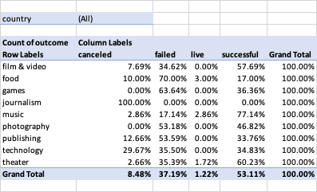



1. **The most successful campaigns were launched during Spring**, more specifically during the month of May.

**Graph 1** – Campaign Outcome by month launched

*N (all cat.) = 4,114*



1. **The campaign success rate decreases with an increasing goal amount** but tends to revert back to mean at 35 – 45K.

**Graph 2** – Campaign Success Rate by Goal Amount

*N (all cat.) = 2,185*



1. **LIMITATIONS**

The current dataset places a few analytical restrictions as it doesn’t provide other key information to allow in-depth analysis. The following are a list of variables that would have enabled us to deep-dive:

1. **Number of “Backers” the campaign reached** : this is know how many backers saw and read through the campaign information but decided not to pledge.
2. **Backers demographics** to show trends and likeliness to pledge would enable predictive analysis into future campaign success rates and help guide future project owners build campaigns that will appeal to backers through accurate wording (*text analysis into key words used in successful campaigns*), presentation and project content.
3. **FURTHER ANALYSIS**

Potential further analysis/graphs could have included:

1. Logistic regression analysis of probable success outcomes.
2. Scatter graphs to show relationship between quantity of campaigns in a given category and success rate.